Untreated observation

1. Update the AF figure

Ancillary features

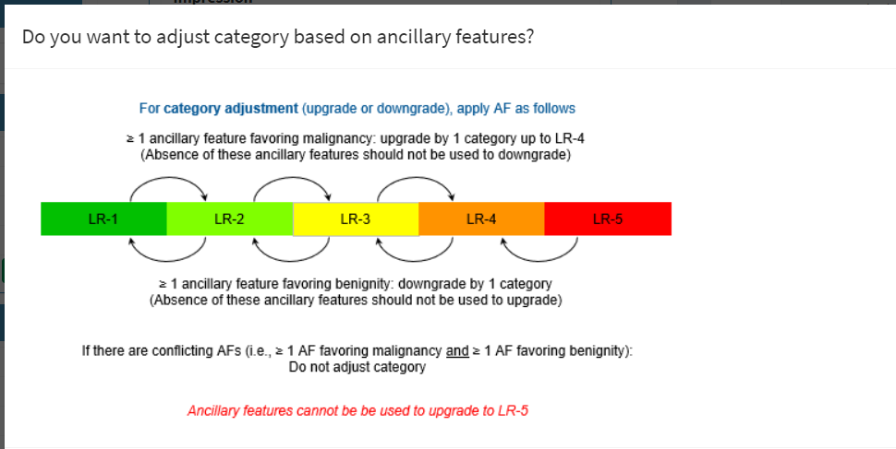

2.

Remove from imaging features of treated observation

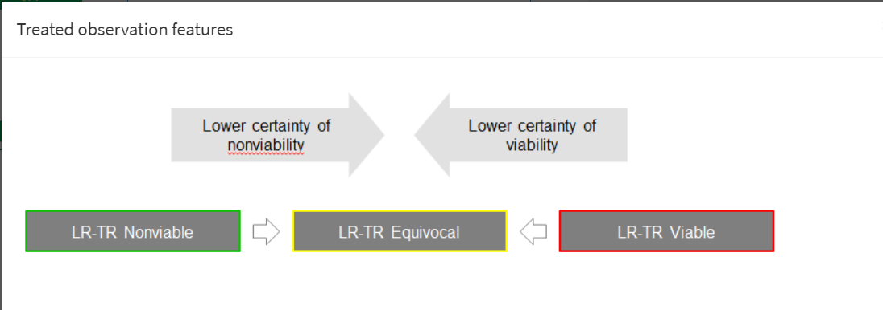

1. Add to “key images” LT-TR algorithm and also to “treated observation imaging features”
2. In the treated observation, if you select posttreatment enhancement as “equivocal” and then go back to “no”, the category remains “LR TR Equivocal” (i.e. does not change to “LR-TR Nonviable”);
3. need output for posttreatment enhancement “No” –LR-TR Nonviable
4. Under “treated observation”, for the “Pretreatment size”, there should be two additional options: “Unknown” and “Unmeasurable”. Alternatively: ask question: Pretreatment size is … (unknown/unmeasurable/measurable); if measurable – “pretreatment size (mm) pops up
5. “Pre-treatment” and “post-treatment” need to have hyphens removed (so should be “pretreatment” and “posttreatment”)
6. Treatment method: add “pick all that apply”, need text box if “other” is chosen
7. Untreated: Change label to “What ancillary features of mal/benignity are present?
8. Series and image # to be moved under Observation for all outputs: **Observation #1 (Image 5, series 7)**
9. Size for LR-1 and LR-2;
10. Add schematics for LR-1 and LR-2 (data element)
11. **Distinctive nodules**

* Ask the size; if >20 🡪 warning
* Remove the question about adjusting based on AFs **only for this choice**
* Add schematics for LR-2 distinctive nodule nod

1. What is the reason for LR-NC category?

* Arterial phase images mistimed
* Arterial phase images degraded by motion/artifact
* Postarterial phase images missing
* Postarterial phase images degraded by motion/artifact
* Other (specify)

1. In treated observation, after “equivocal”, need do ask the size of the enhancing component

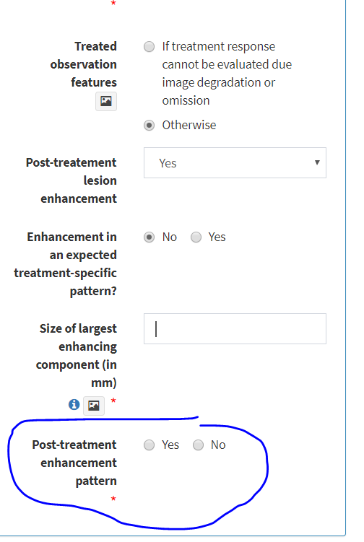

This should not be a yes/no question; this should be a list with multiple selectable features

1. Add size of enhancing component to “Equivocal”
2. Choices of vessels in “TIV” should not be capitalized
3. For TIV:

If parenchymal mass is “YES”, targetoid features “yes”, need Size of parenchymal mass and need choices of targetoid

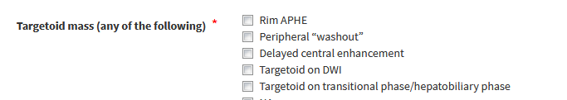

If “yes” is selected, the LR-M features is listed as “none”; output should mirror that of LR-M

1. Under “Liver segment”:
   1. add “Segment” to choices I-VIII
   2. remove “Liver segment” for the default output in “Impression”
   3. add 4 figs under “segment”
2. Move “schematics for obs and high risk population” under “observation in high risk patient”

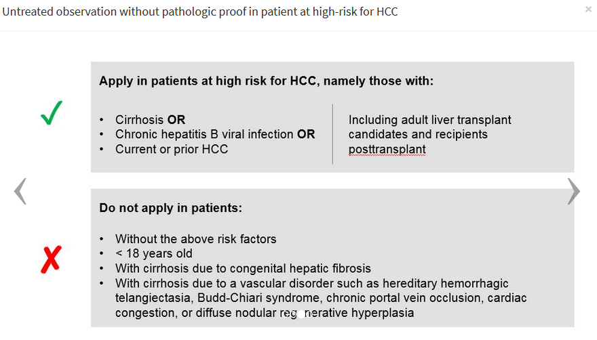

1. In LR-M:
   1. Change the labels to “Targetoid LR-M features (any of the following)” and “Nontargetoid LR-M features (any of the following)”
   2. Remove “N/A” as options for both
   3. If one of the choices selected under “targetoid”, “nontargetoid choices should NOT disappear (same is true for reverse)
   4. “other features that in radiologist…” change to “other” and free text option
   5. Add figure for targetoid mass
   6. Add figure to Nontargetoid mass
2. Threshold growth: if the user selects “yes”, 2 new questions come up:
   1. What was the size on the prior study (mm)? – numerical output
   2. What is the time period since the prior study (months)? – the output is numerical, accepts values less than 7
   3. **Report output:** Threshold growth: Yes (prior size **XX** mm on the study **YY** months ago)
3. Algorithm figure to be added under “Untreated observation without pathologic proof in patient at high-risk for HCC”

Data elements: Date and modality – automatic extraction? Type of contrast agent for MRI? Patient level: age (can be computed based on DOS and DOB) and sex – To ask Marc Kohli